# **IMPLEMENTING CRM FOR RESULT TRACKING OF A CANDIDATE WITH INTERNAL MARKS -(ADMIN)**

CH.PRAVALLIKA(TEAM LEADER)

B.DEEPIKA(TEAM MEMBER)

CH.DHANA PAVANI(TEAM MEMBER)

G.BHAVAMI (TEAM MEMBER)

M.SAI RANI (TEAM MEMBER)

M. DURGA BHAVANI (TEAM MEMBER)

**Step 1:**

**Create Account by Using Salesforce Developer. signup**

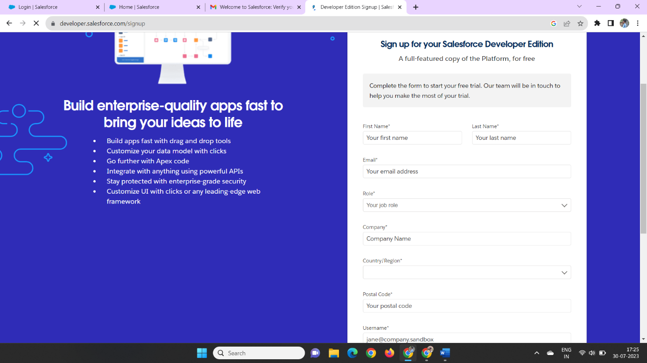

**Step 2:**

**Firstwe Create the Developer Edition then We receive Mail Through the Salesforce**

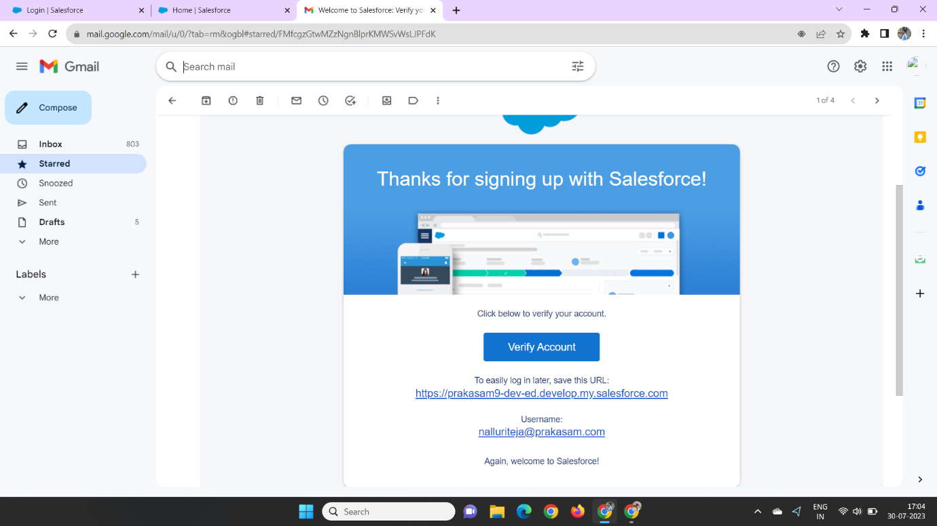

**Later we Can Create the Password by Using the Manner**

### **Step3:**

### **Creation of Semester Object for Candidate Internal Result Card**

In Those Manner We Can Create Semester Object in The Object manner That Way We Can Create aCandidate, Course Details, Lecturer Details and Internal results

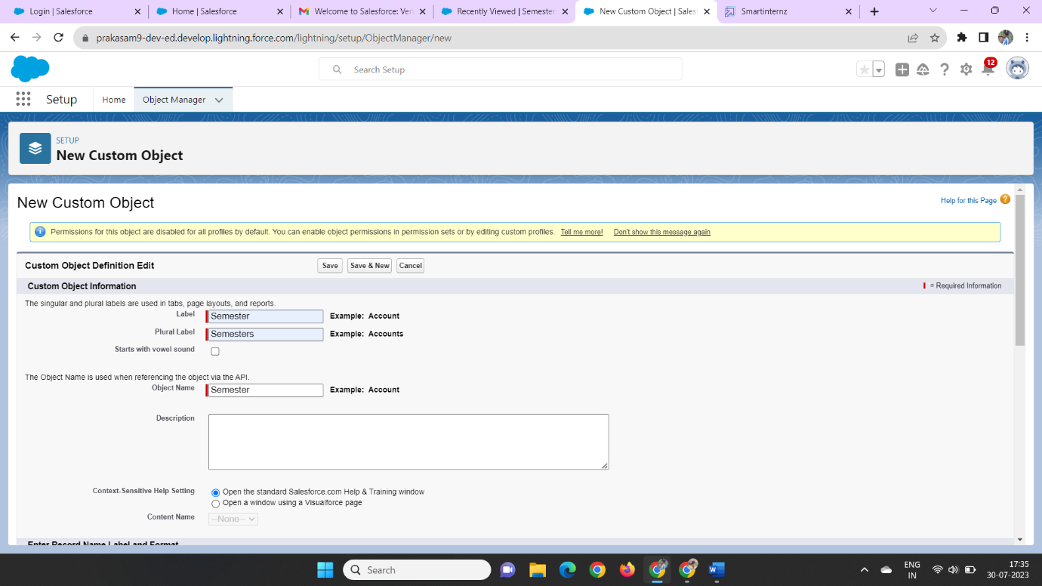

And Click the Checkbox Allow Reports, Allow Search

Step4:

Creation of Semester Tab for CandidateInternal Result Card

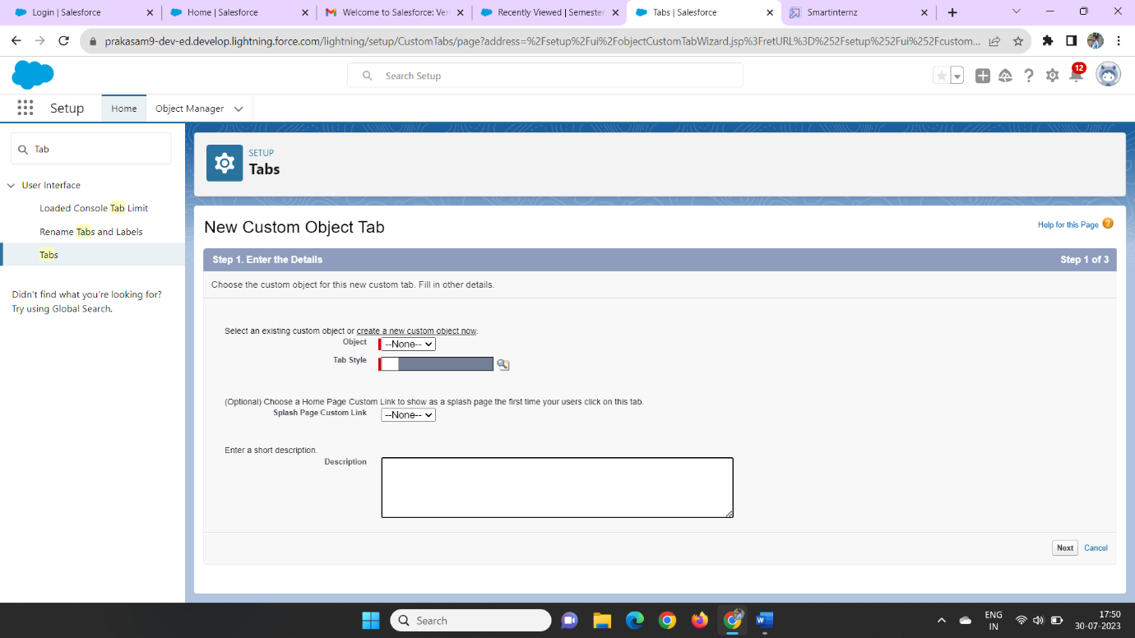

Now We Can Create the Custom Object Tabby Using the Given Data.

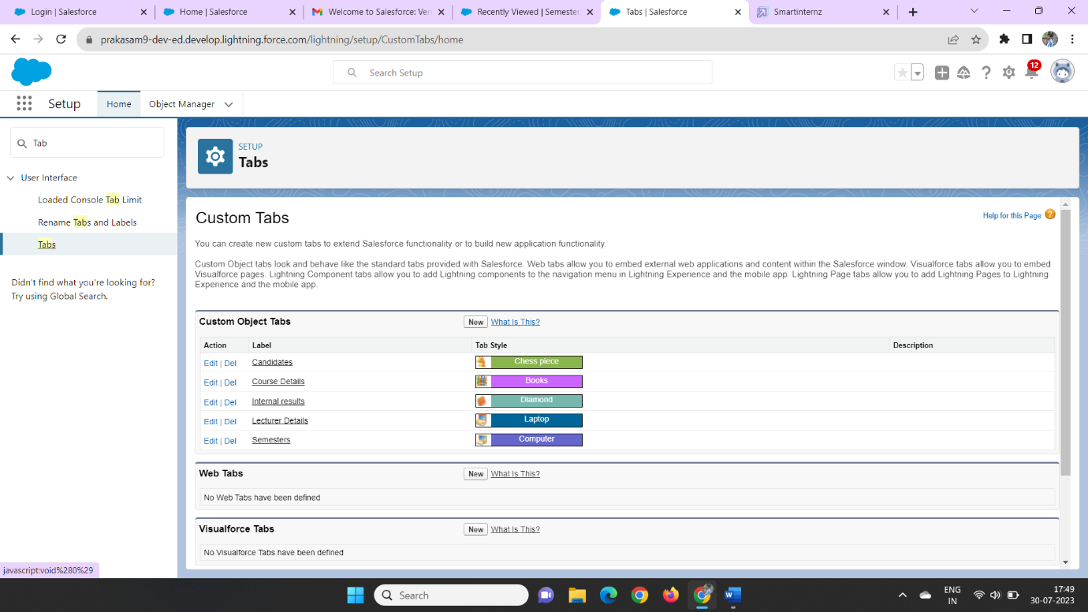

### **Step 5:**

### **Create The Candidate Internal Result Card App**

Now We Can Create aNew Lightning Appby Using App Manager

In Those Manner We Can Create a**Candidate Internal Result Card** as the App Name

Now Click On the new Lightning app and create a new app managerial

The App Manager can be Change use to show the data of the creation of the data manner of the containing to show the data of the progress

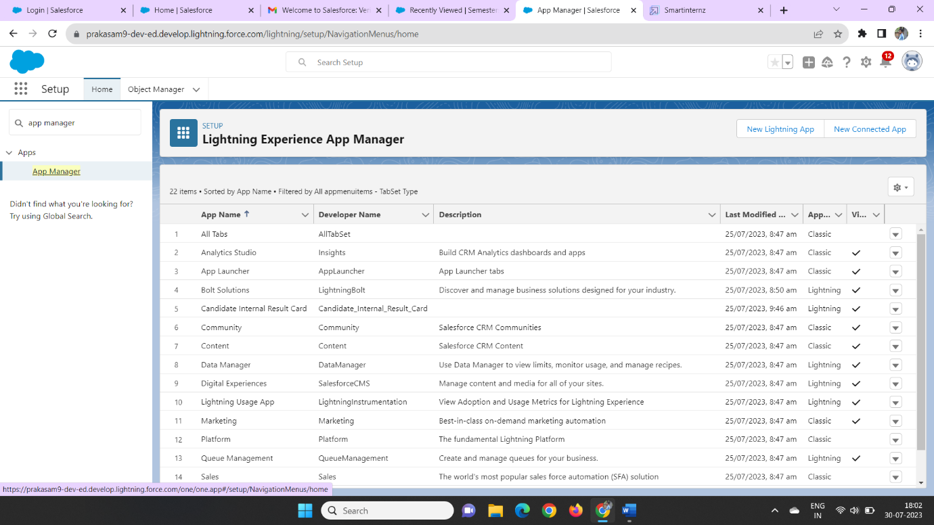

In those we Can Create a New lighting App

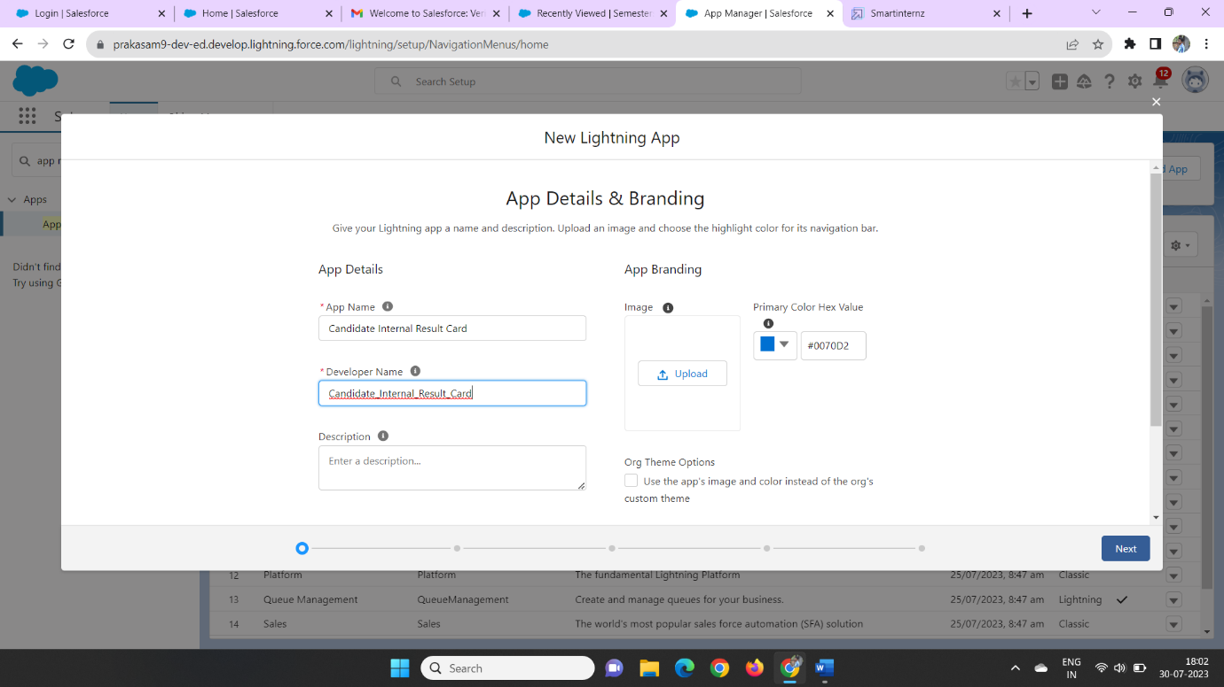

Then We Can Create the App Name as Candidate Internal Results Card

Later we Can Click next, Next Then we Can Drag the **Semester**, **Candidate**, **Course Details**, **Lecturer Details**, **Internalresults**, **Reports**, and **Dashboards**on The Right Side of the column

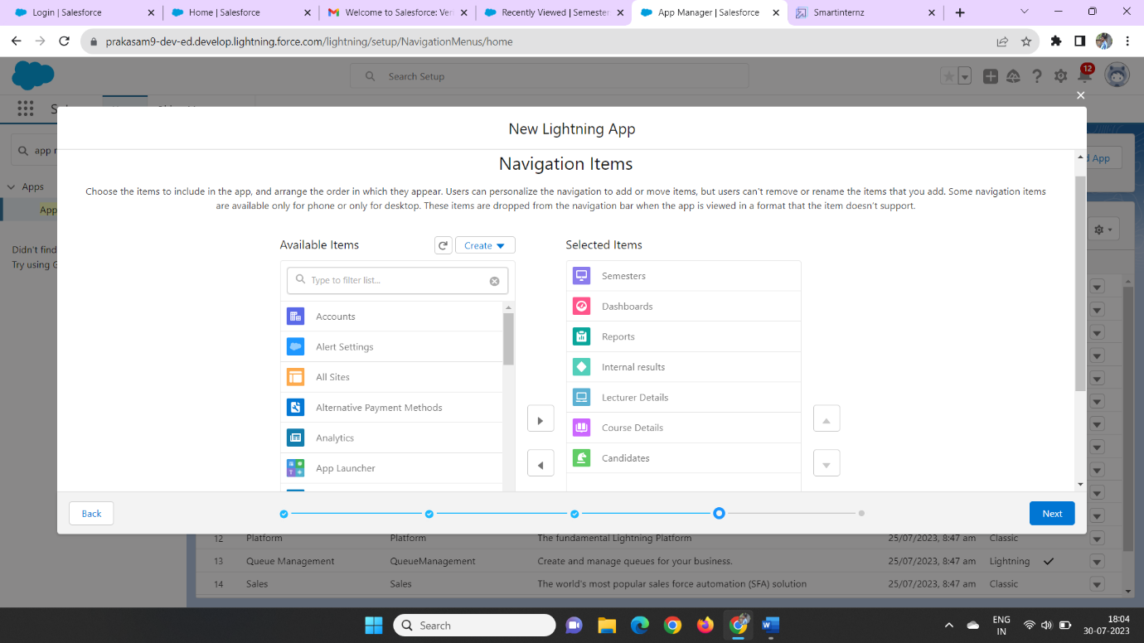

Then We Can Click Next Object Then We enter System administrator Profile and Click Save &finish.

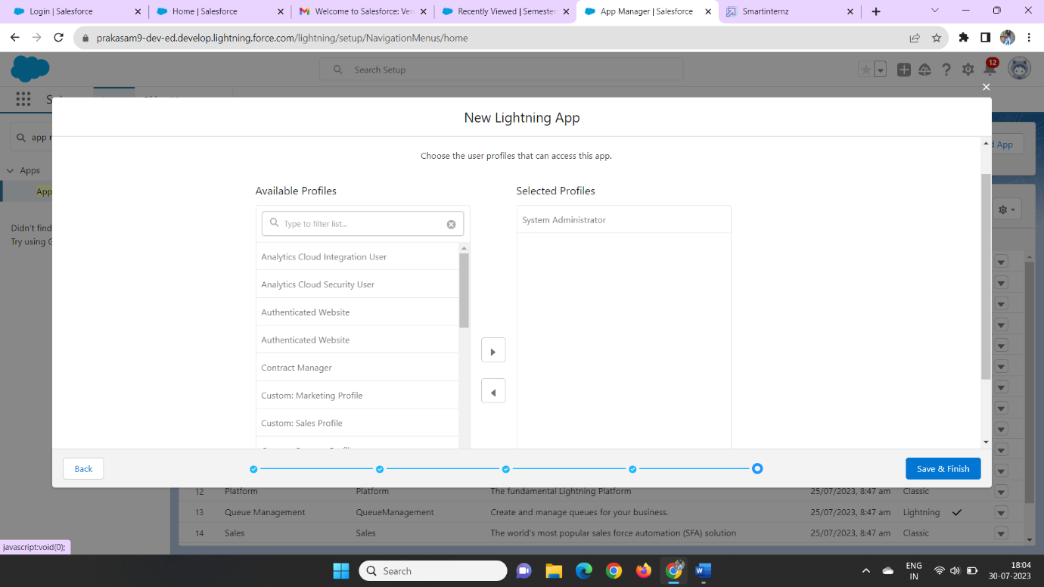

### **Step 6:**

### **Creation Of Text Field On "Lecturer Details" & Look Up Field for the “Candidate” Object**

In Those Manner We Can Create a Lecturer Field Data on the on The Text Data type

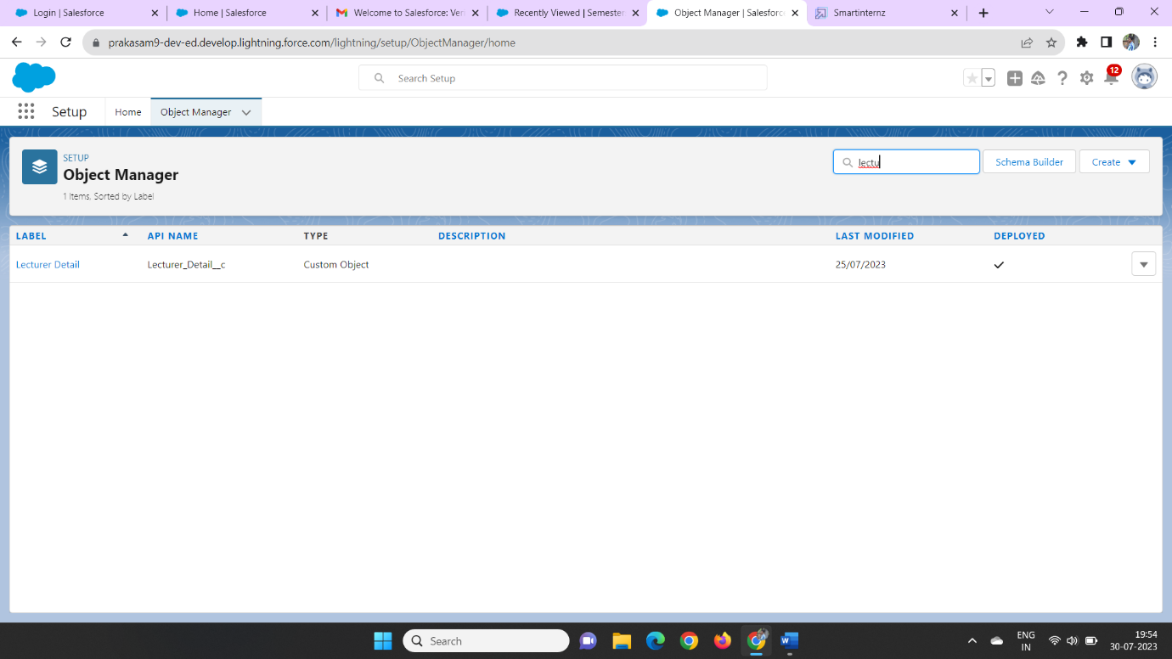

We Can Enter The Data type on the field object then we can enter the lecturer role as the data type

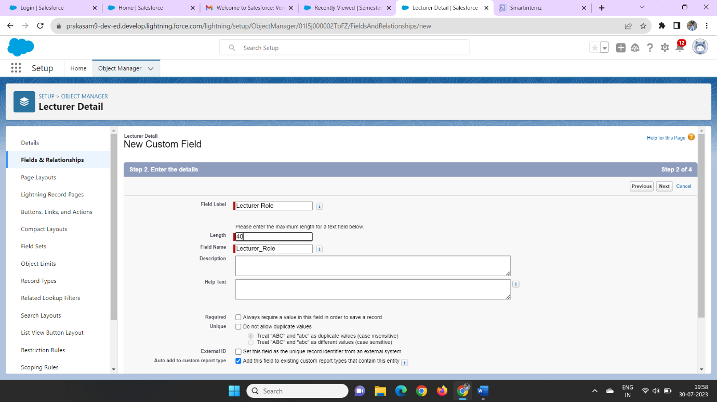

Later we can click next, next &save

In those we can create a lecturer role on the field label

Later we can create a new candidate field in the Fields& Relationships

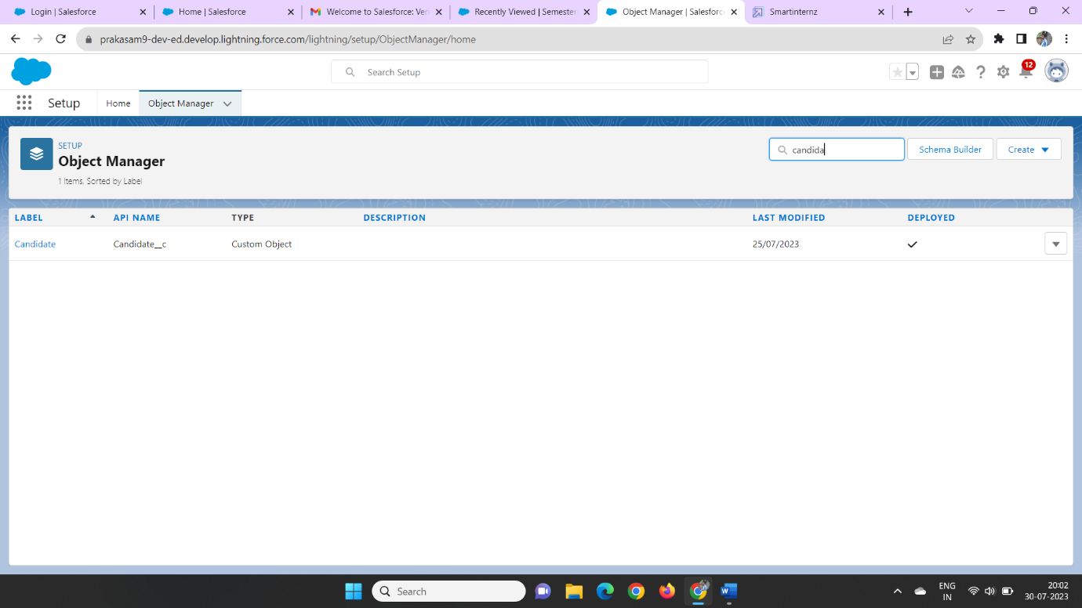

In those We can new look up data type on the fields &relationship

Later we can click on the Semester object to the related object

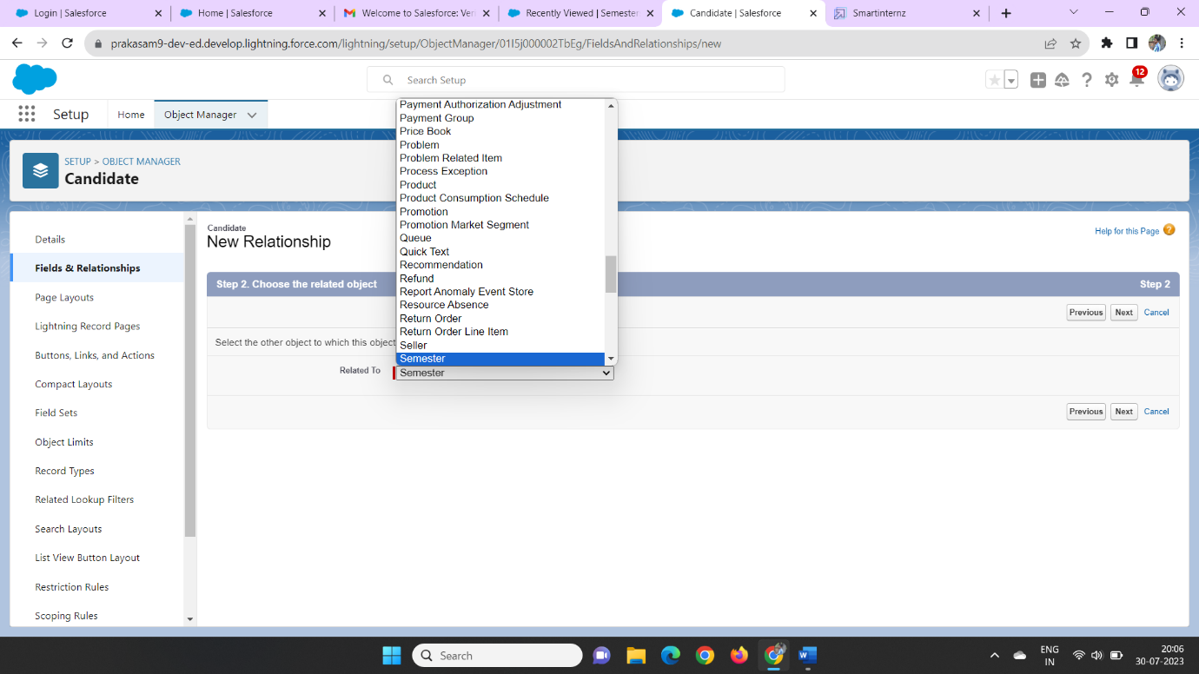

Then we can enter the next step we can add a field label name as Semester number and field name as Semester-name

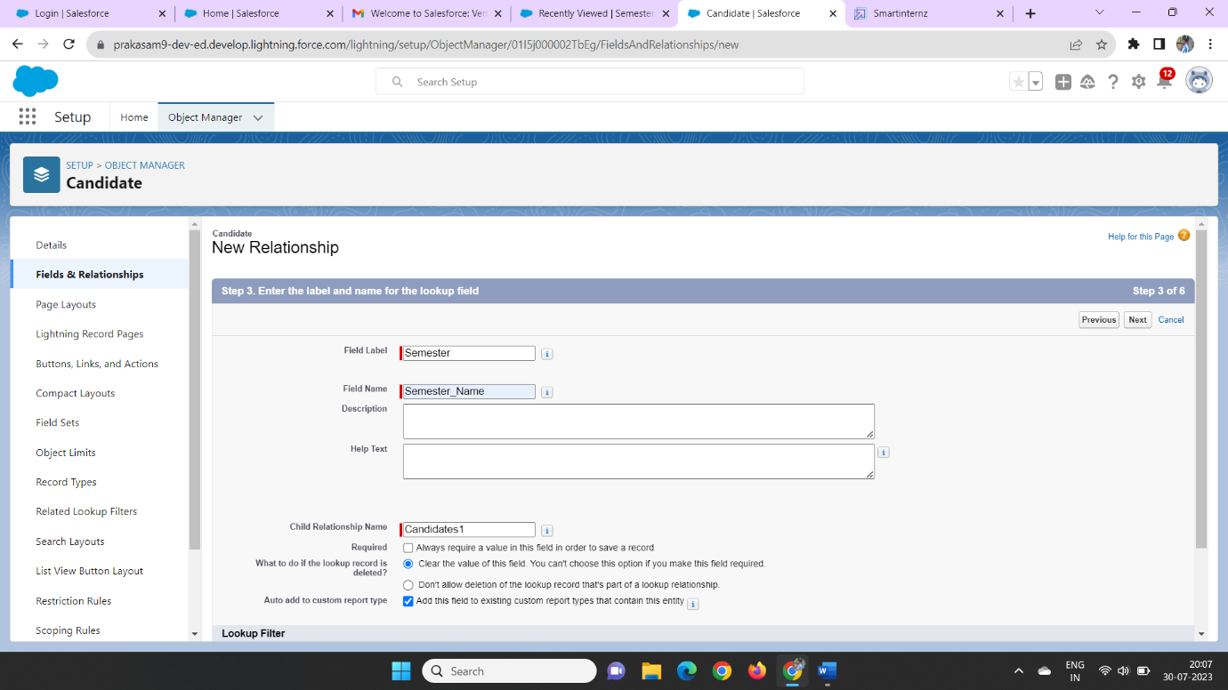

Then click Next, Next, Save.

Then we can create the Candidate object, Course Detail Object, Internal Results Object and Lecturer Details object on the above manner

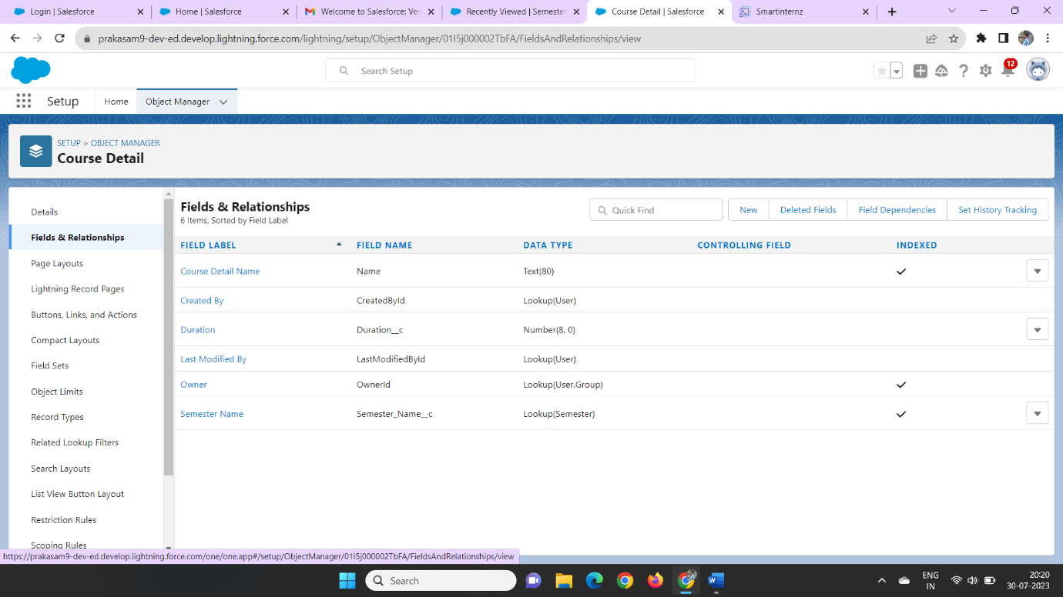

In those we can create a Semester Fields on all the Candidate, Course Details, Lecturer Details & Internal Results

**Step 7:**

### **Creation Of Auto Number Field on Candidate Object, Number Field on Course Details Object & Formula Field Course Details Object**

In This manner We can create a coursedeta through the fields & relationship manner we can enter data type as number field

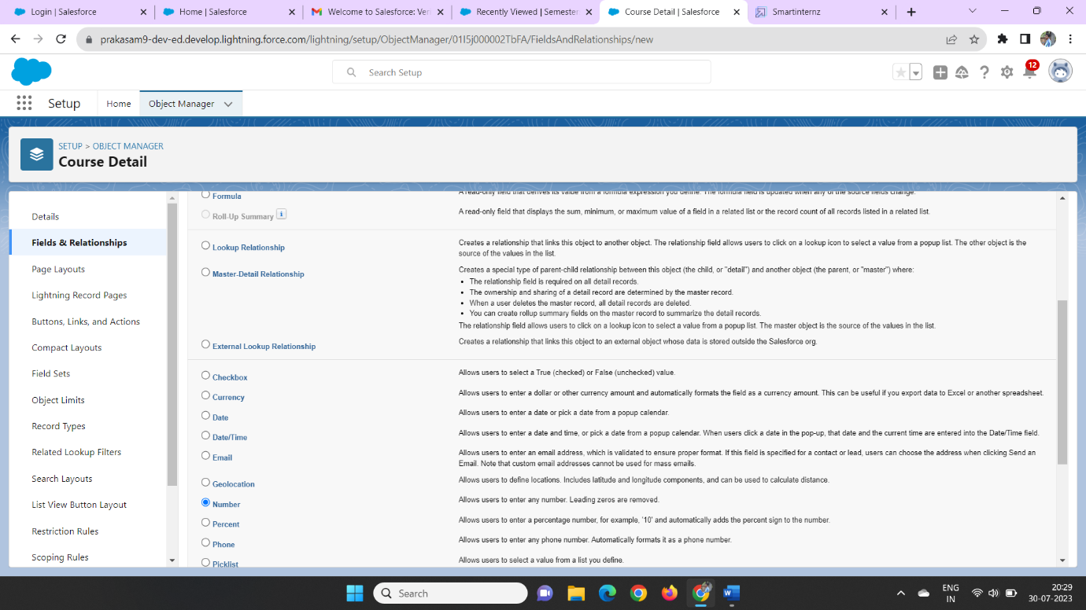

Later We can enter the field label a duration, enter

Then the help text was Enter Course duration value in Years

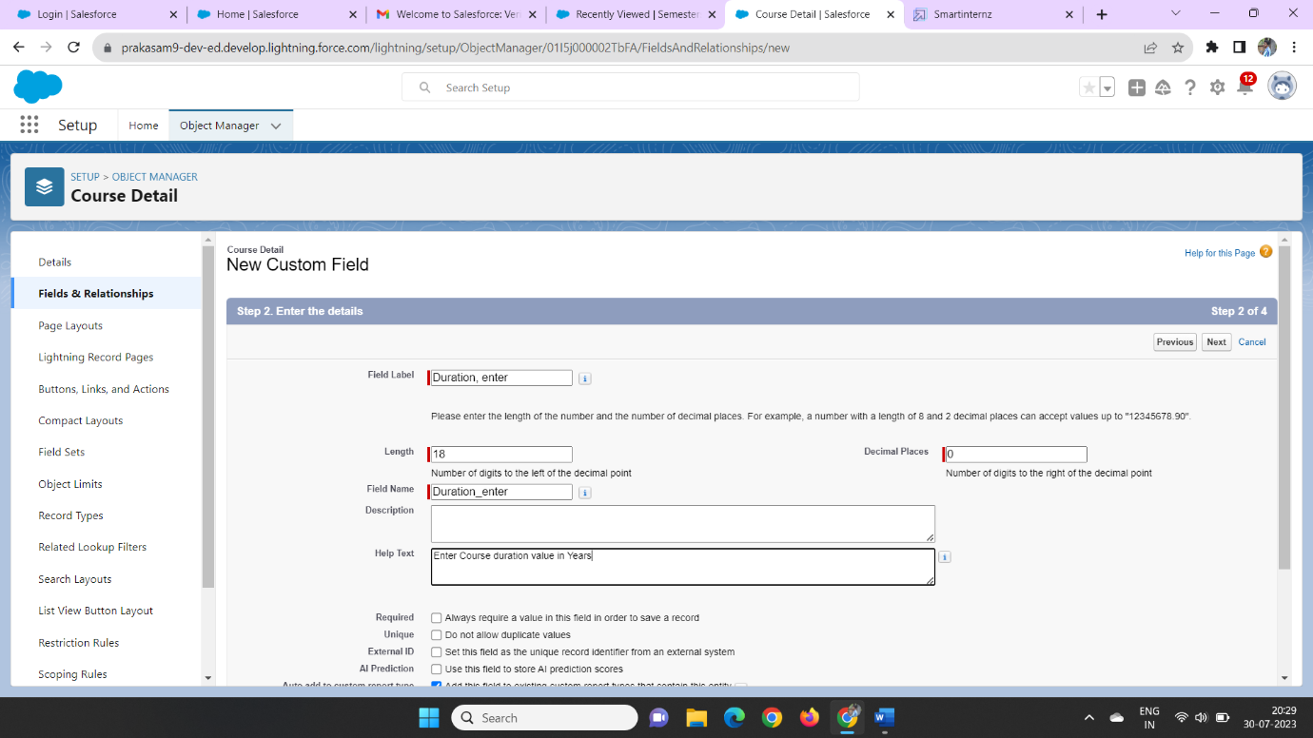

Then click Next, Next, Save

In those we can click on theobject manager and search as Internal results as on the quick find

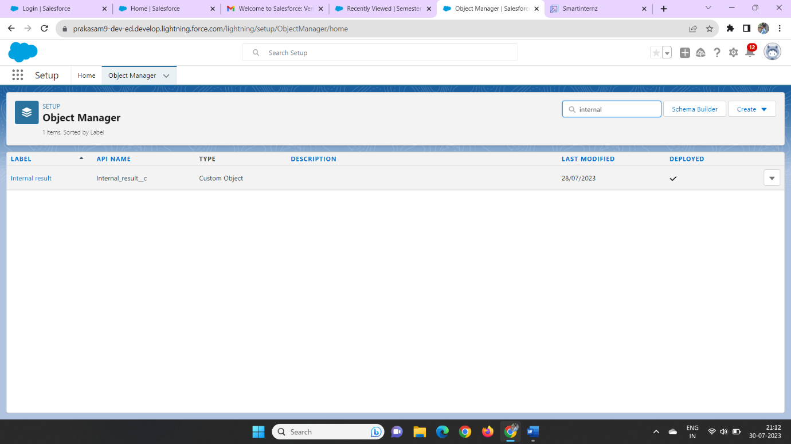

Then we can click on the field and relation and click new field enter formula as a data type

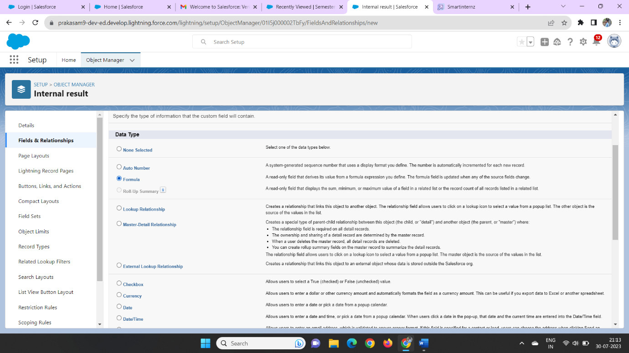

Then we can enter the field name as candidate roll number and click text as a data type

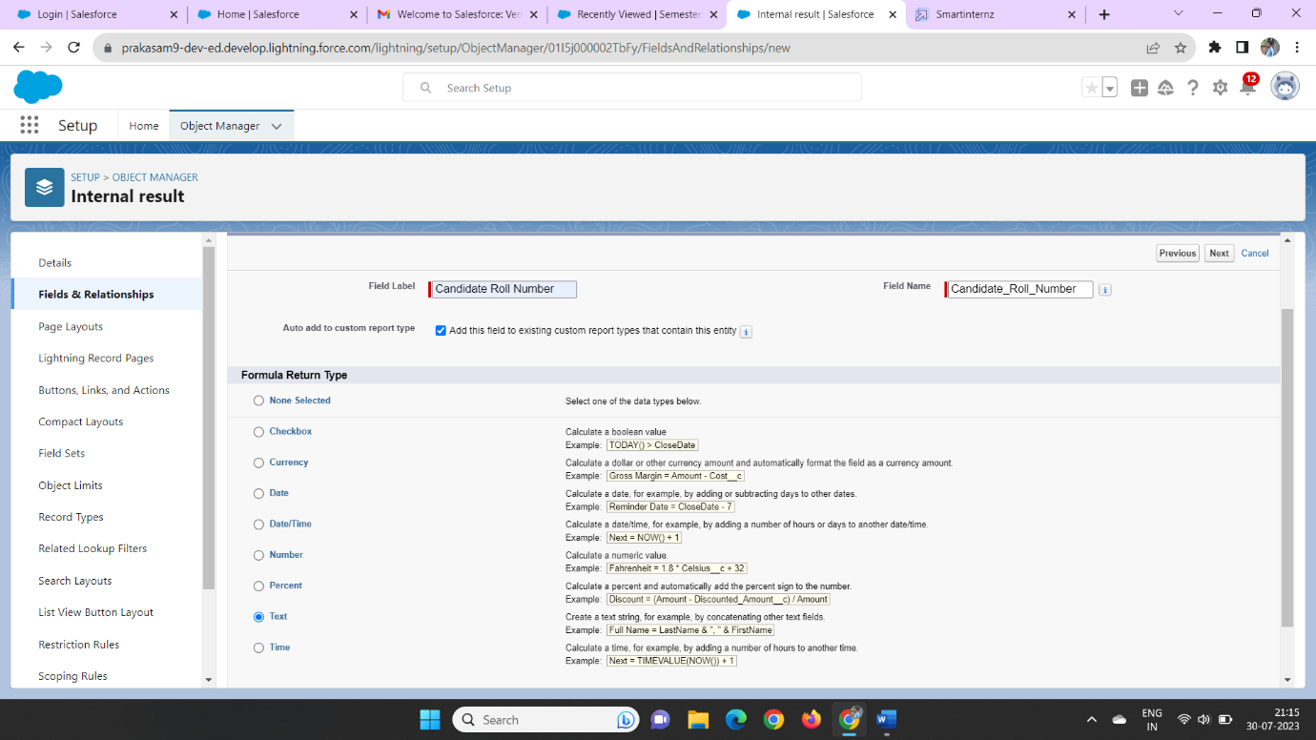

Then we can enter on the insert field as the candidate roll number and click the check syntax

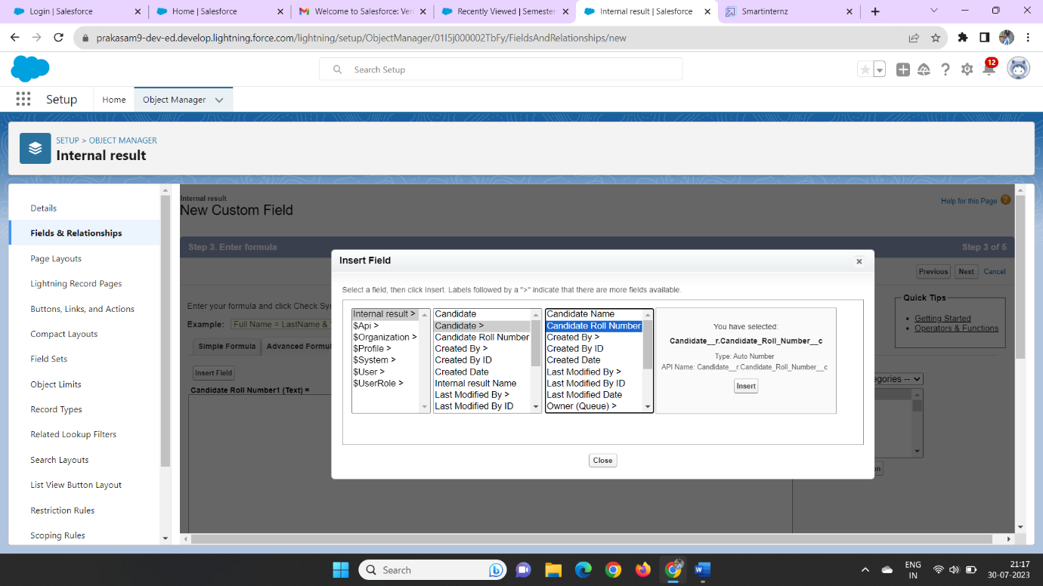

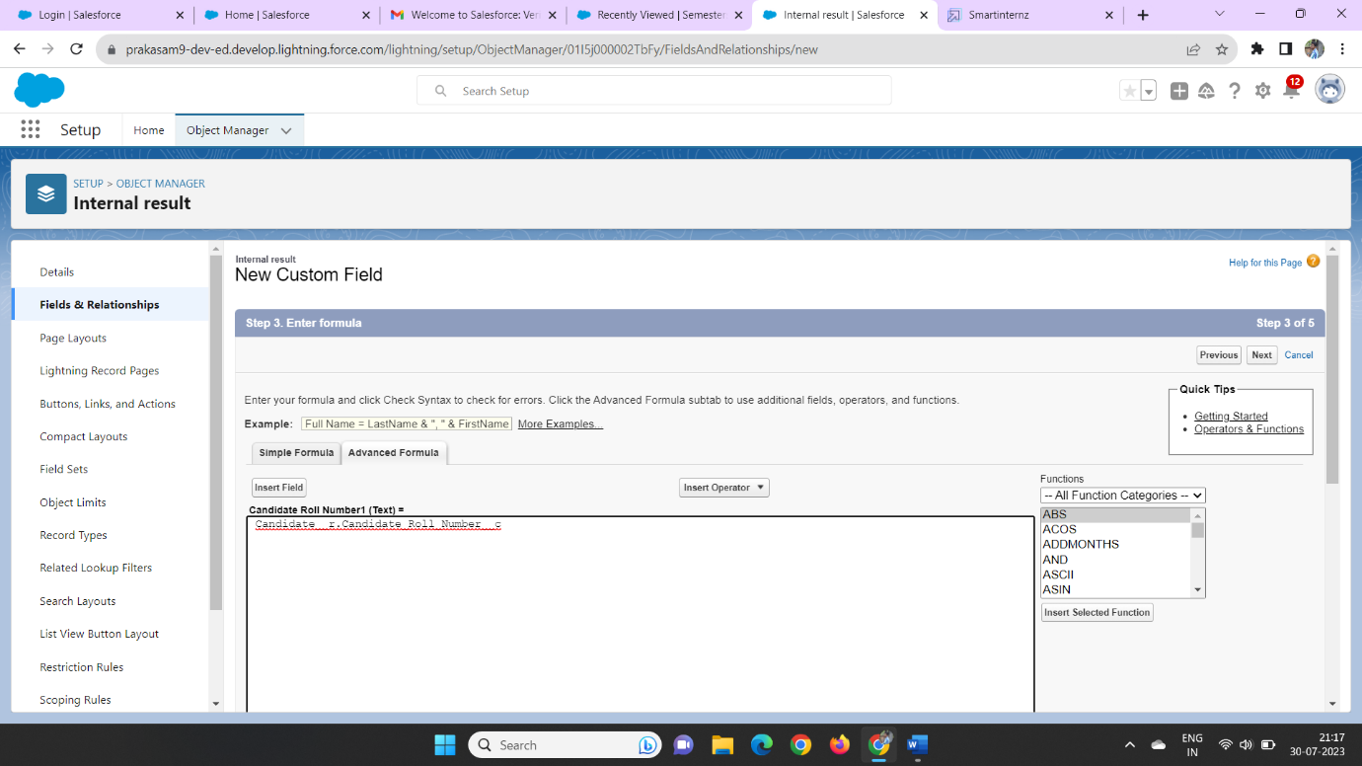

Then click on Next, Next, Save

Later we can create a data type on candidate object on the fields and relationship then we enter the data type as auto number

We can enter the candidate roll number as the auto number cr-{0000} as the auto number of the formula

**Step 8:**

**Creating Users**

In the users we can be create a user in those we can click on the home and click on the quick find box then enter user then click on the new user

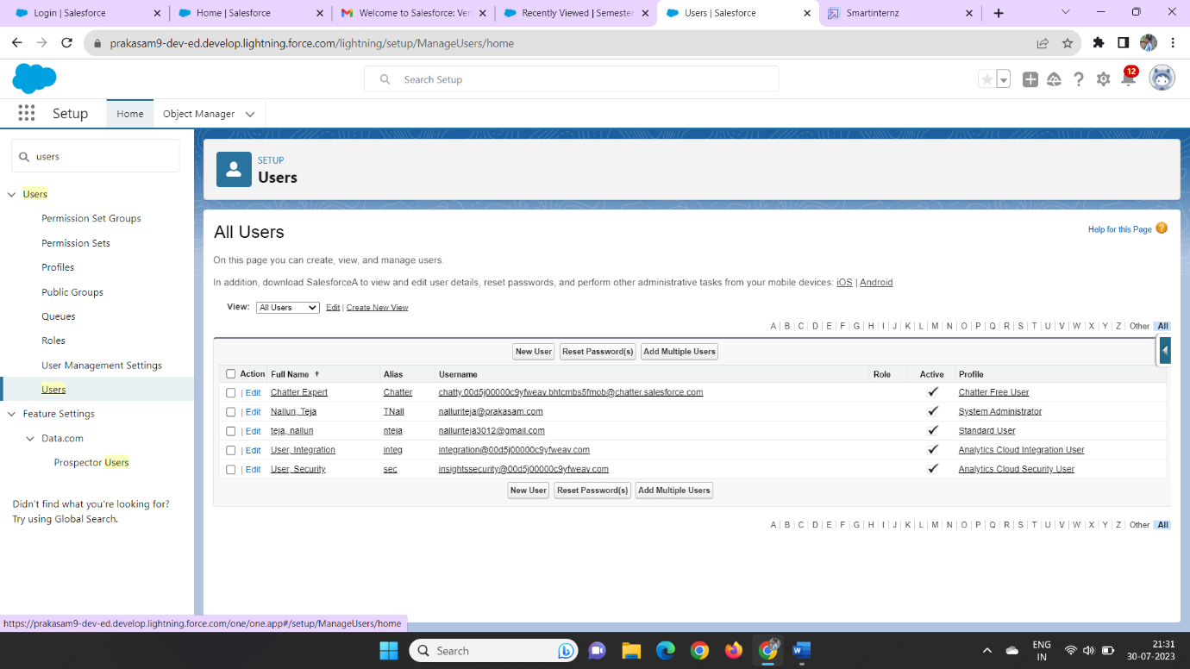

We can enter the first name last name and username

Click on the user licence as salesforce and profile as standard user

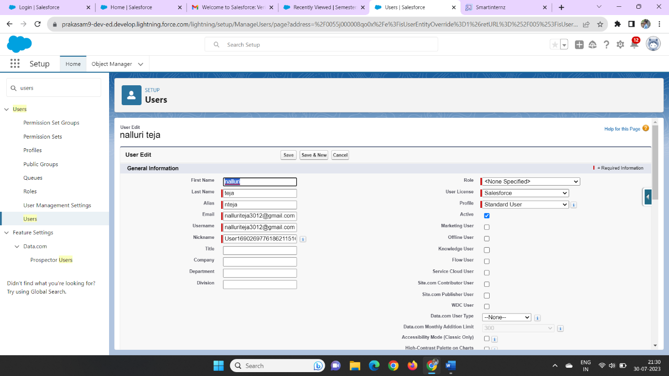

And click on the generate new password for login users of the data

**Step 9:**

**Create Records**

Now click on the app launcher on the left side of the screen

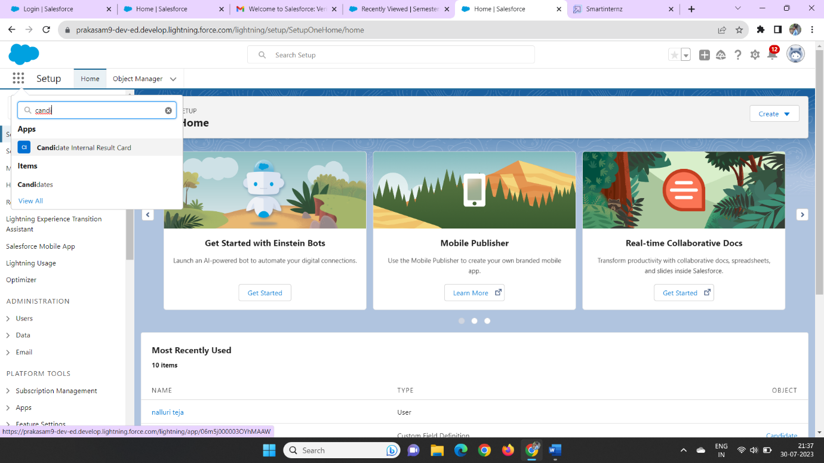

Click the candidate internal results card on the app launcher

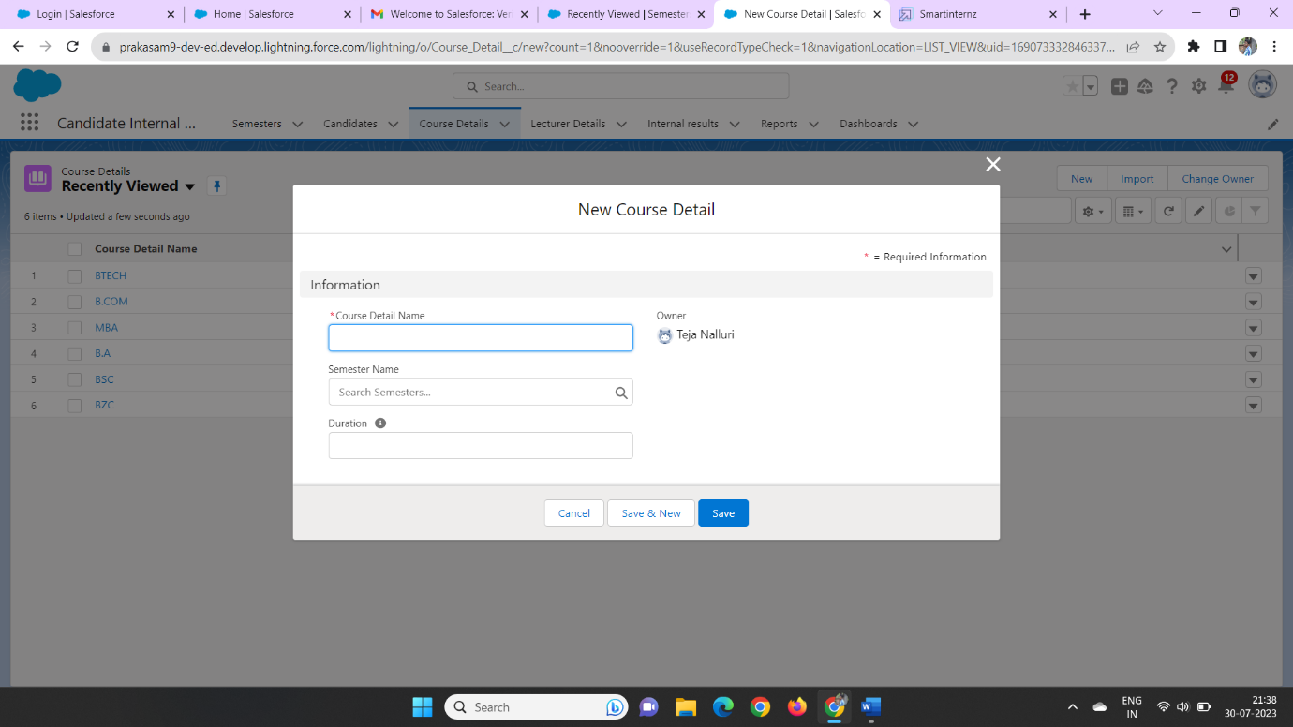

Then we can enter the course details on the tab click new and enter the course details

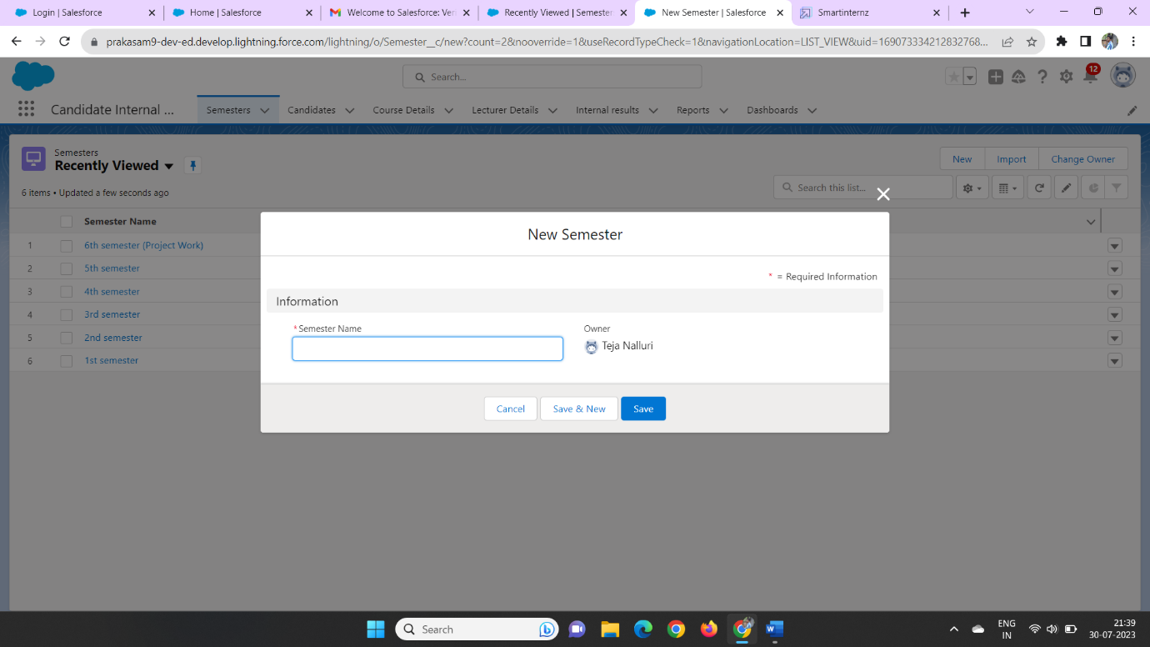

Click on the semester tab and create a semester on the tab

**Step 10:**

**View Records**

click on the app launcher and search as candidate internal results card

Then we can view the created records on the semester field and course details field

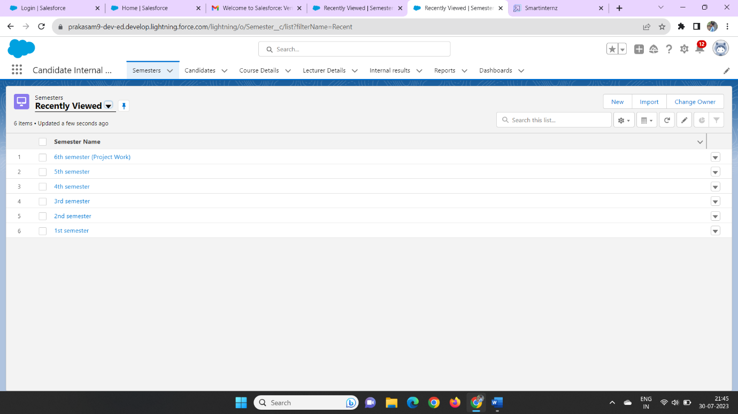

**Step 11:**

**Delete Records**

We can click on the app launcher and search as candidate internal results card

We can delete the fields on the created of the data

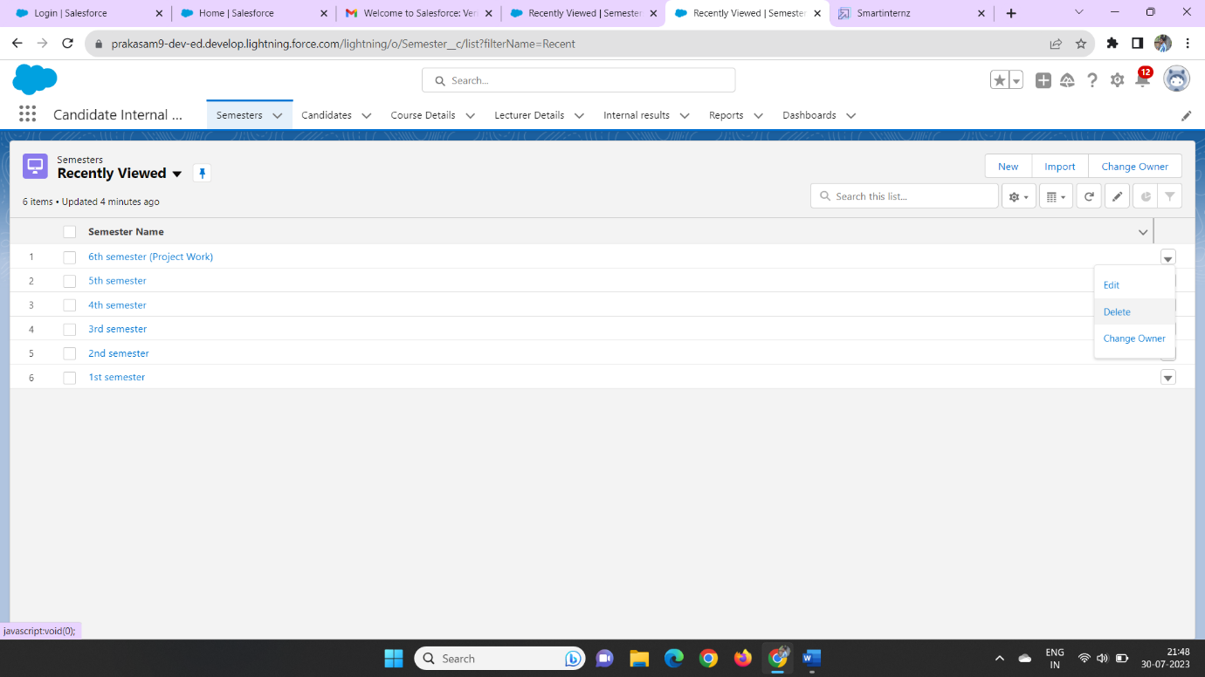

In those we can delete the records on the object

**Step 12:**

### **Create Report**

We can click on the app launcher and search as candidate internal results card

Click on the reports tab and click on the new report and click on all

And enter the course details with semester name

And click on start report

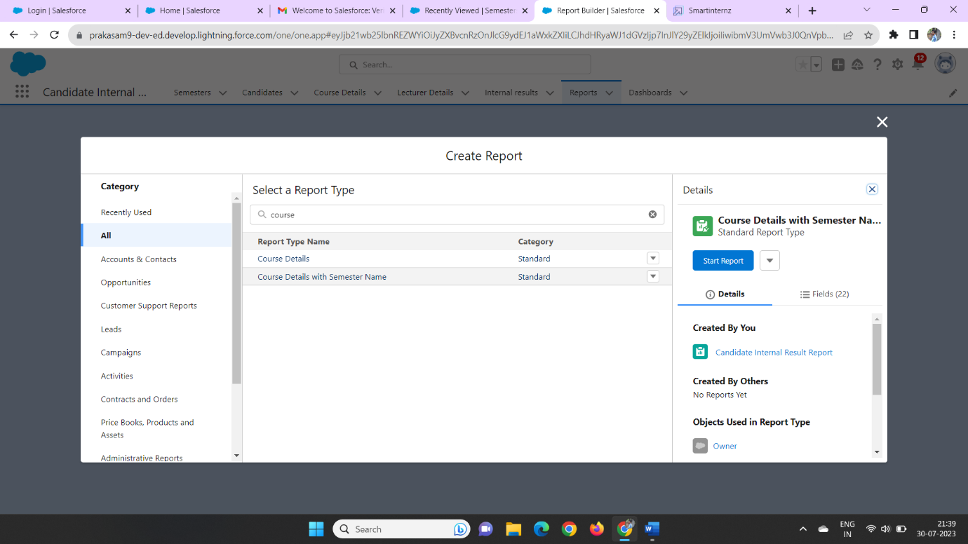

Then we can enter the data as group row as course details as course detail name in group row field

Group column as Duration on the data

Column as course details as owner name

And create a bucket column of the data

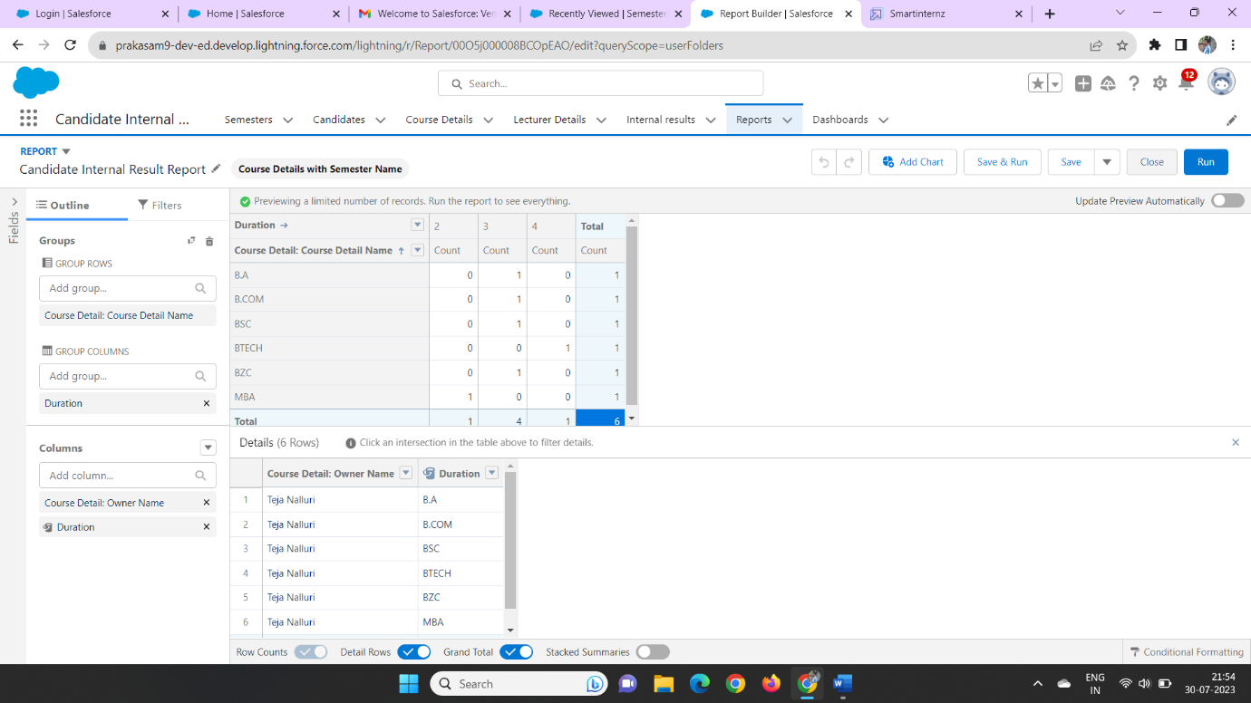

Then click and save and run

We can enter the Report name as Candidate internal results report as on the private folder

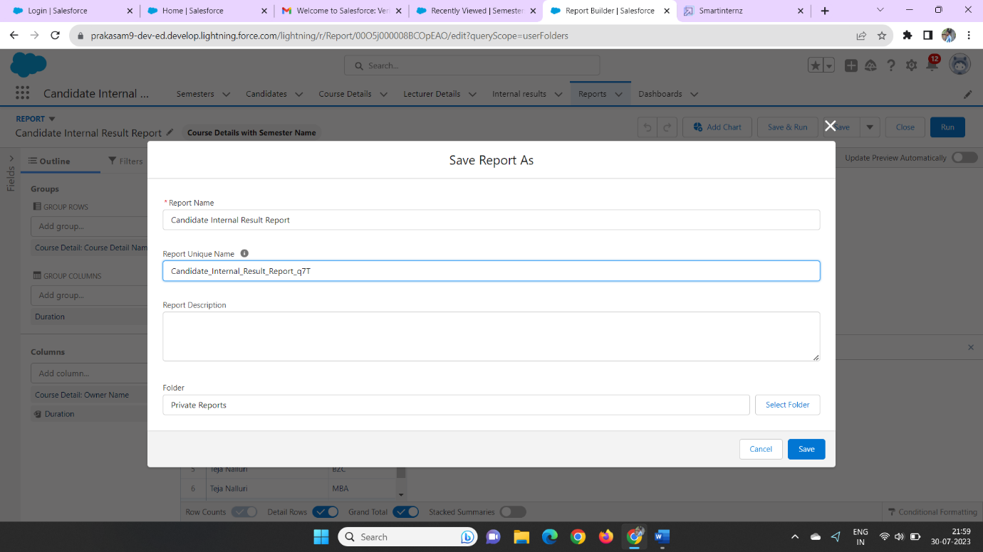

S**tep 13:**

**View reports**

click on the app launcher and search as candidate internal results card

click on the reports tab

we can check the reports tab

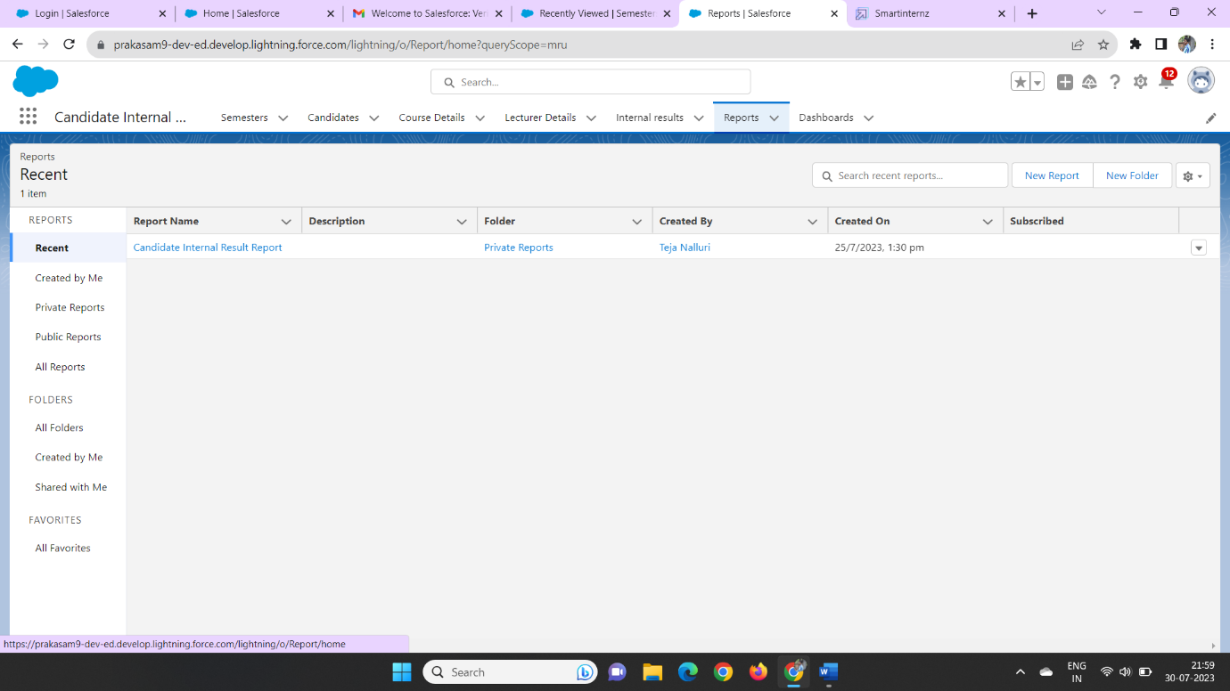

**Step 14**

### **Create Dashboard**

click on the app launcher and search as candidate internal results card

we click on the dashboard and create a new dashboard

with thw name of candidate internal result card

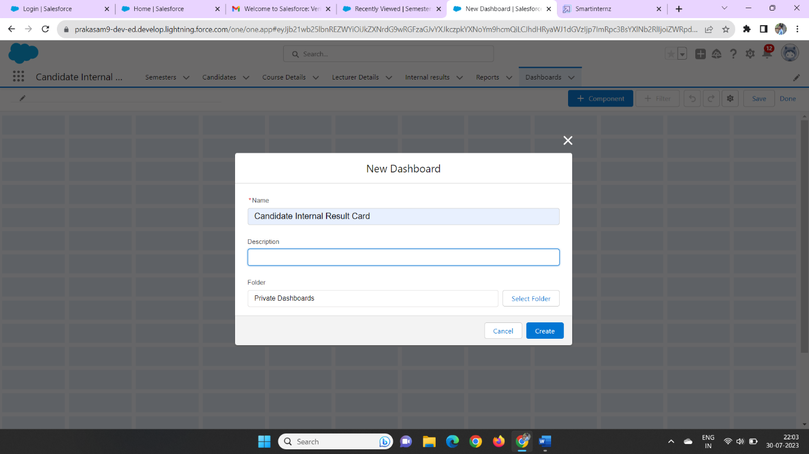

Then we can click on the + component and create a dashboard data

Then we click on the candidate internal report dashboard

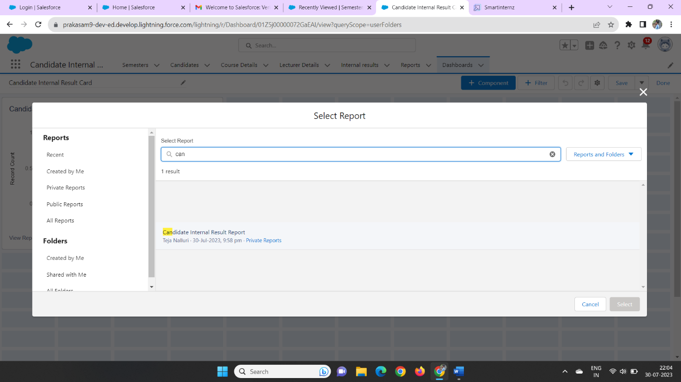

Later we click on the report we select the data on the field

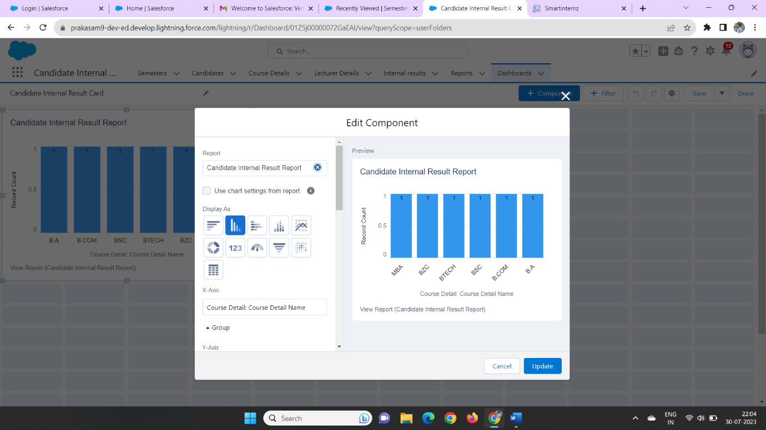

Then click on the finish it will be created

**Step 15:**

**View Dashboards**

click on the app launcher and search as candidate internal results card

click on the dashboard tab and we can check the dashboards

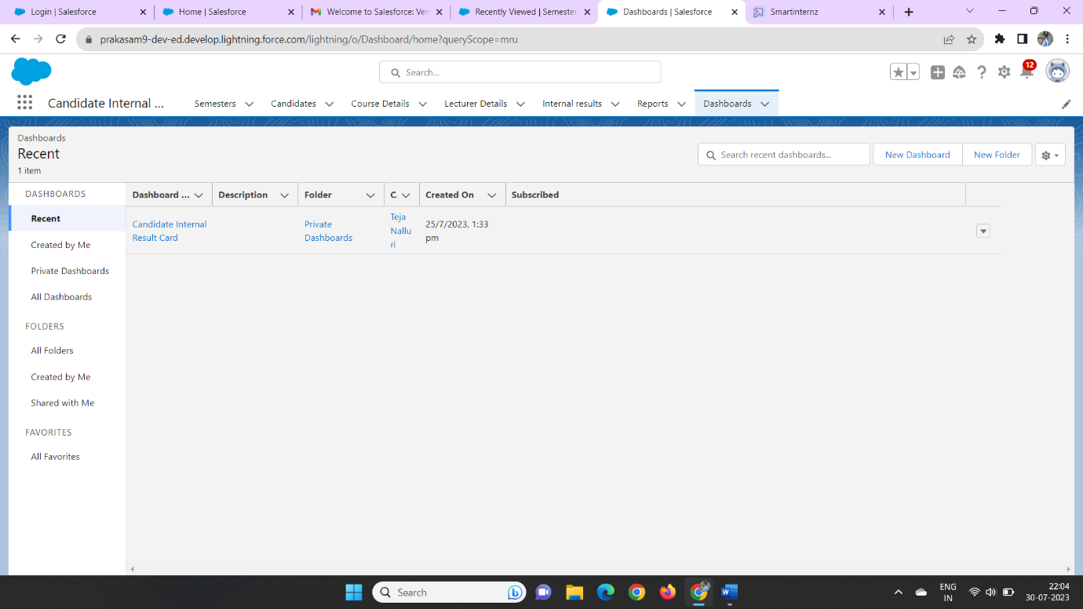

Then we can click on that dashboard we can see the created dashboard

